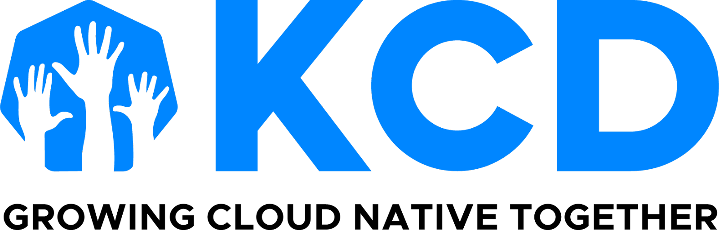

KCD Monthly Organizer Digest

February 28, 2025

As February ends, we look forward to getting one month closer to KubeCon + CloudNativeCon in London! Thank you for your KCD nominations for the one (1) scholarship we were able to give away for this event. We had so many great nominations that we were able to split our budget of $1,500 USD into two scholarships.

We had many qualified recipients and two (2) teams who submitted more than one person, which automatically disqualified them from being chosen. Congratulations to teams Bengaluru, and Warsaw, for your nominees earning their scholarships. 🎉

**OPPORTUNITY**

Are you already planning to attend KubeCon + CloudNativeCon in London? We will have our usual project pavilion kiosk, which lives among all the CNCF projects in one area (not paid sponsors). This is where the end users will be, so it's a perfect audience for your KCDs!

If you are interested in using this opportunity to promote your upcoming KCD, please gather with your team and agree on a time slot to sign up for. We try not to give more than one slot to the same team, as we also have this available for community group organizers to promote their meetups. But please do be sure to let us know if more than a one-time block works for you and your team.

| [**Sign Up**](https://forms.gle/eqDg8bcd61iq7eGP9) |
| --- |

And if you have yet to register, don’t forget you get a 50% discount as an organizer, and can share a 15% discount with your community.

* KCEU25O50KCD 50% - KCD Organizer (not to be shared outside of your KCD team)
* KCEU25O15SHR 15% - KCD Organizer Shareable discount for KCD attendees

**BEVY PAY NOTIFICATION**

For those concerned about the many incomplete payments in Stripe, I dug deeper with Bevy and discovered that the problem can be easily triggered if one does not proceed beyond the “Order Now” button.

As always, please let me know if you see any other alarming behavior like this, as I am your advocate and will help find a solution or answer.

**IDEA AND INQUIRY**

Our CNCF training lead brought an idea and inquiry forward for Kubestronuats. What would you, as organizers think of giving the following discounts to that program?

* 20% discount for Kubestronuats
* 100% discount for Golden Kubestronuats

Your opinion matters, so let us know your thoughts.

| [**Kubestronaut Discount Survey**](https://forms.gle/n6AKYR61YAnXsQ8r6) |
| --- |

As always, thank you for helping spread the knowledge of cloud native in your spare time!

**Audra Montenegro | audra@cncf.io**

**CNCF Community Program Manager**

**US Time zone: Pacific**

**KCD** [**GitHub Repository**](https://github.com/cncf/kubernetes-community-days/blob/main/README.md)

**KCDs on​ Social Media |** [**LinkedIn ​**](https://www.linkedin.com/company/kcds-by-cncf/)**|** [**X/Twitter**](https://twitter.com/KubernetesDays)